April 18, 2022
“It’s not personal – it’s strictly business”

Dear Client,
Fifty years ago, Francis Ford Coppola’s directorial masterpiece, The Godfather was in theaters. It is hard to find a list of top-ranked films without this classic occupying one of the top three spots.
Marlon Brando was a phenomenal actor, with a long list of film credits, but it is hard for me to see anything other than the image of the mob boss when I think of Brando. Coppola and Mario Puzo, the author of the book, were convinced Brando had to be The Godfather. Paramount flatly refused the suggestion. The 47-year-old actor (Yes! He was just 47 when he played the role) had developed an infamous reputation for being very difficult to work with. Coppola, undeterred, went to Brando’s home to convince him to create an audition tape. The actor stuffed his lower jaws with tissue and smeared black shoe polish before reading a few lines and even taking an impromptu phone call in character. Once the studio reviewed the tape, they were convinced. Brando won an Academy Award for playing the crime boss but refused to accept it.
If you have not seen the film or have not watched it in a few decades… take the time. I recently rewatched and it is as good as I remembered. You know a book/movie is good when fifty years since it is still regularly quoted, and it seems every Mob movie or show since pays respect to The Godfather.
Everyone who knows the franchise has a favorite quote…
“I’m gonna [sic] make him an offer he can’t refuse.”
“Leave the gun, take the cannoli.”
“Revenge is a dish that tastes best when served cold.”
One of my favorites is an exchange between Michael and his girlfriend, Kay.
Michael: My father is no different than any powerful man, any man with power, like a president or senator.
Kay: Do you know how naive you sound, Michael? Presidents and senators don't have men killed.
Michael: Oh. Who's being naive, Kay?
That said, the one line that comes to mind most often for me is, “It’s not personal – it’s strictly business.”
While our primary business is personal, working with and advising families on their financial affairs is deeply personal. Our relationship with investments and the companies we own is strictly business.
As human beings, it is one of the most difficult things we do, separating emotions from evidence when it comes to investing. There have been thousands of books, papers, articles, and even congressional reports produced on the topic. The Library of Congress investigated and compiled various research on the topic entitled “Behavioral Patterns and Pitfalls of U.S. Investors.” The conclusion of the report states the importance of education and transparency as “….an essential means of preventing investors from committing a predictable series of mistakes.”

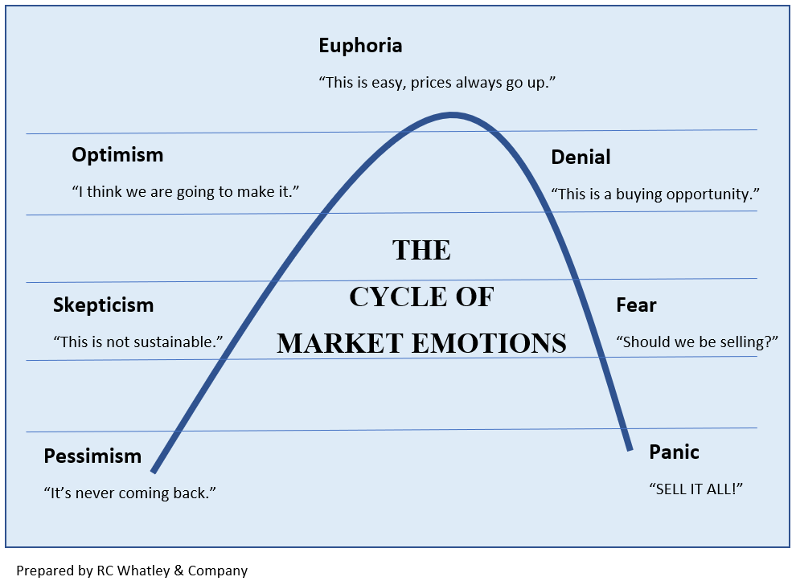
A lot of this can be summed up in a concept referred to as the cycle of market emotions. Generally speaking, as the economy, our businesses, our jobs, our investment portfolios improve we tend to have more confidence and tend to be willing to take on more risk. Inversely, when these items have an extended downward trajectory, we become increasingly fearful.

In short, it is in our DNA, part of our fight or flight response, to want to be more aggressive at economic and market highs and more conservative at the lows.

It is irrational to think that Michael Corleone would not take the assassination attempt on his father personally. It is equally irrational to believe that we, investors, would not take a threat to our savings, future, and family welfare personally, that we would not be emotional. The important thing is not to act on those personal emotions, but to pause and reflect on what is happening, focus on the evidence, and treat it as, “…strictly business.”

No one can predict exactly where we are in the market or the cycle of emotions. That said, we continue to study, monitor, and execute our strict process for managing assets and serve as your “consigliere.”

Thank you,

Financial Advisor

‘The Godfather' was released 50 years ago. Sourced from - https://www.insider.com/trivia-about-filming-the-godfather-2020-8
Behavioral Patterns and Pitfalls of U.S. Investors. Sourced from - https://www.loc.gov/rr/frd/pdf-files/SEC_Investor-Behavior.pdf

